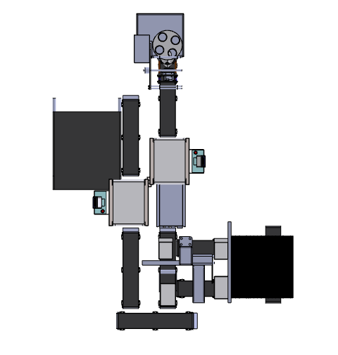
AUTOMATION SOLUTION-DIVISION

ITC Spices Automation
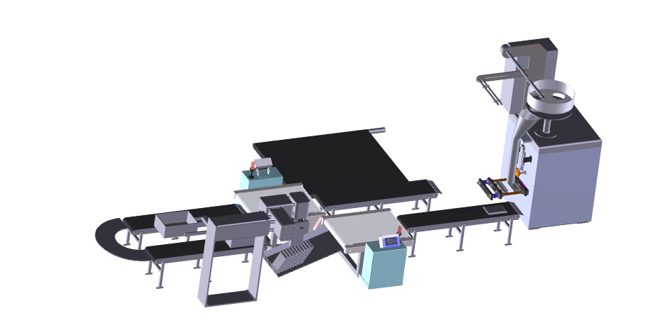
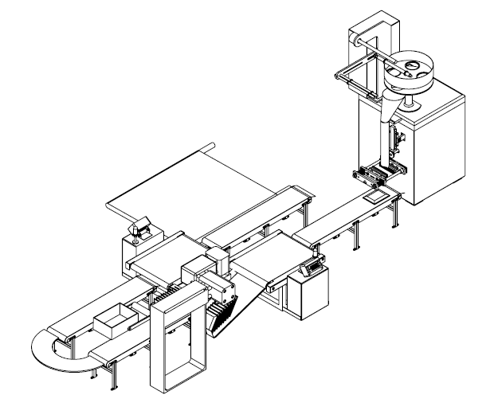
Proposal:
- Packing
- Sorting
- Filling
- Inserting
We Make Possible

ITC Limited

Guntur, Andhra Pradesh,

Attn: Mr. Kiran Kumar

Dear Sir,

Thank you for giving us an opportunity to participate with our offer on the above project. We enclose herewith our proposal which includes:

- Requirement
- Scope of Works
- Pricing
- Technical Specification
- Terms & conditions

Requirement

- Energy efficient Design: The secondary packing line should be energy efficient. The design shall ensure minimum possible power.
- Equipment Reliability: Downtime of the secondary packing automation should not be more than 2%. The line should ensure no choking or tare of the pouches, trays and boxes.
- Check weighs: Primary packed pouches must be checked for their weights to ensure that they are within the specified limits, if they are not within the specified limits they must be diverted to slitting section.
- Stacking of pouches: The accepted pouches must be stacked into specified number, which may vary depending on SKU’s before being boxed. The pouches must be placed vertically into the tray. The details of SKU’s and quantities have been given in annexure.
- Tray and lid folding: The trays must be folded automatically and be positioned for the placement of stacked pouches. Lid has to be placed over the tray for closer.
- Sealing and labelling: The trays closed with lids must be sealed with tape automatically, simultaneously the labelling must be done. The labelling should be highly accurate with minimal levels of tolerance.
- Feedback systems: There must be feedback systems for the following
  - Pouch counting: The number of pouches accepted must be counted before being stacked, which shall be giving feedback to primary packing machine and laminate printer for stopping when required number is reached.
  - Packing extra: The auger count has to be controlled form the feedback provided by the check weighs, which shall be ensuring the acceptance and rejection of the pouches depending on the specified limits so that packing extra is reduced.

- Data collection: Data should be gathered from all possible points of the system. Few of the main points would be like start and stop data of machinery, number of pouches being packed, number of pouches being rejected, weight variations of pouches, number of boxes being sealed. It is preferred if we can print few data online at the end of each run like start, end time and number of pouches packed.
- Safety: Secondary packing automation should comply with industrial standards of safety, occupational health and hygiene as per industry norms. For example:
- Provision of limit switches, where necessary
- Guards for belts/ pulleys
- Isolator switches for machine maintenance
- Flexibility: The automation has to be flexible in order to accommodate variations in pouches, lids and trays in future if required without much changes from the actual system.

SCOPE OF WORKS:

The scope of work shall be exclusively on secondary packing. This includes collection of pouches from the VFFS packing machines, checking the weight of the pouches, stacking the pouches into tray, closing with the lid, sealing & labelling the box and weighing the box.

For the above scope, following set of activities are expected to be performed:

1. Design and development of secondary packing automation.
2. Development of site drawings for secondary packing automation.
3. Budgetary proposal for procurement, installation and commissioning of secondary packing automation with break up.
4. Project implementation plan.

Drawings

We will issue a full set of shop drawings for approval within 2 weeks of receiving the confirmed order and finalized design details

Compensation clause

Please note that in the event the buyer cancels an order, after the order is confirmed to us, it is binding to the buyer to pay NIHVA a compensation of 25% of order value.

General Prerequisites Required at Site
1 | Finished Flooring after curing (Without Water)
2 | Electrical Supply on the site single phase/three phase points at different places.
3 | Provide electrical cables near to the installation machinery
4 | Fork lift/crane to be provided if required .
5 | Scaffolding require for Installation it is in client scope.
Limit of Supply
1 | Provide place to store the material to be installed .
2 | Be responsible for the safe custody of all material.
3 | Provide place to safely store all the tools of installation
4 | Provide change & rest room for the workers.
The supply included only those mentioned in the quote & does not include
1 | Unloading from truck placement on site
2 | Electrical connection for Panel
Client Scope
1 | Once our project gets complete for any additional work to & fro loading &boarding of our service  technicians is in client scope
2 | Any civil / masonry/structural work required to support are in client scope

Training, warranty, maintenance and service agreement

Training

After installation of the automation system, we will train the Clients personnel in the operation and basic maintenance, including the understanding of the error codes on the control system (if applicable).

Warranty

The warranty period is twelve months from the date of installation and commissioning.
OR 13 months from date of installation & commissioning.

If a defect arises within the warranty period stated, which is attributable to faulty design, materials or installation workmanship the product will be repaired at our discretion without charge. This guarantee is subject to proper use of the product and assumes that the product is regularly serviced and maintained by skilled personnel in accordance with the operation and maintenance instructions supplied.

Maintenance and Service Agreement

We would suggest that you take advantage of a maintenance and service agreement on the NIhva products, which will guarantee trouble free operation and speed of response in an emergency. Customized proposals are available on request.

Packaging & sorting system:

PRICING

Sr No | Description | FFS | Price in  INR/Each | Total Amount  In INR
1 | Packaging & Sorting System | 1 No’s | 43,65,000 | 43,65,000
2 | Packaging & Sorting System | 2 No’s | 76,00,000 | 76,00,000
3 | Installation charges for above system | No’s | 3,80,000 | 3,80,000

- Technical Specifications:

1 | Carton erector with 1 adjustable magazine
a> Small Conveyor
b> Pneumatic vacuum based Pickup assembly
c> Same pick up assembly for two magazine
d> Capacity :- 15-20 Cartons/min
e> Power Supply :- 3 ph 440/220v 50Hz
f> HMI control input
g> PLC Control Panel
h> Working Height :- maximum 2000mm tentative
 | Rates: 12,30,000
 | Note:- Carton erector with 2 adjustable magazine Rates: 15,90,000
2 | Pouch stacker conveyor with servo control
a) this palletizer work after check weighed
b) Working speed adjustable as per check weighed speed
c) Due to servo control accuracy is very high
d) Food Grade belt
e) SS structure
 | Rates : 5,30,000
 | Note:-For Extra pouch stacker Conveyor price will be double
3 | Take up conveyor with VFD for 1 FFS
a) Take up conveyor for speed matching of check weighed and FFS
b) Motor is as per Annexure
c)VFD is provided to adjust speed
 | Rates : 3,10,000
 | Note:- Take up conveyor with VFD for 2 FFS Rates : 1,50,000
4 | Carton sealer
a) Tape Size :- 3"
b) belt Speed :- 10m /min
c) Power Supply :- 3 ph 440/220v 50Hz
d) Motor is as per Annexure
 | Rates : 5,00,000
5 | Pouch weighed with tolerance of 1% 100 PPM
a) 120 PPM adjustable
b) Highly accurate in motion weigh and reject equipment is offered with
several weight indicator and line speed option.
c) Provides bulk total and feed rate to an accuracy of +/- 0.5% to 1%
d)capacity :- 100gms to 1kg
e)Belt speed :- 20 to 35 mtr/min as per selection of weight

 | Rates : 10,00,000
 | Note:-For Extra Weigher prices will be double
6 | stacker Assembly with collecting Arm
a) Servo based fix rotation ARM
b) Pneumatic action figure
c) Action start after input signal from previous system
d) figure will be change according to product size
 | Rates : 4,95,000
 | Note:-For Extra stacker Assembly Price will be double
7 | Labelling and Roll Selector
 | For 1 system Rates : 3,00,000
 | For multiple system Rates: 7,00,000

- Terms & Conditions:

1 | Price |  | : | Ex Works Pune
2 | P & F Charges |  | : | Extra 3 % |  | on supply value
3 | Freight Notes |  | : | Extra at actual
4 | Delivery |  | : | 12-14 weeks from the date of receipt of confirmed purchase order, Advance  Payment, Drawing approval.
5 | Payment |  | : | 100% advance against supply + 100% taxes against delivery at site
 |  |  |  | 100% cost of installation against installation & commissioning
6 | Insurance |  | : | Extra As applicable
7 | Sales Tax |  | : | Extra as applicable at the time of dispatch. Presently @13.5% VAT  (supply within Maharashtra OR @2% CST against Form C (Outside Maharashtra)  Or GST will be applicable if required.
8 | Service Tax |  | : | Extra @ 15%
9 | Validity |  | : | Validity of Offer is 15 days from the date of quotation
10 | Warranty |  | : | 12 months from the date of supply.  Or 13 months from the date of supply.
Please feel free to contact Mr.Mayur Derle on 7709209333 For any further Clarification /Information in this
concern.
With Best Regards
Pooja Badre
020-66304033
For NIHVA Technologies Pvt. Ltd

